Page Yields
Declared versus Actual
Why can’t I get the number of prints the cartridge says it can do?

Often, when you are purchasing a cartridge for your printer, you could be told that the cartridge can print up (x) number of pages or images. This number is calculated on the amount of ink or toner in the cartridge and how much ink/toner would be used to cover 5% of the page.

What this means is that if you are not printing documents or images that are exactly 5% in coverage (very few, if anyone does), then the number of printouts you will get out of a cartridge will differ from the number of pages the cartridge states it will print (declared yield)

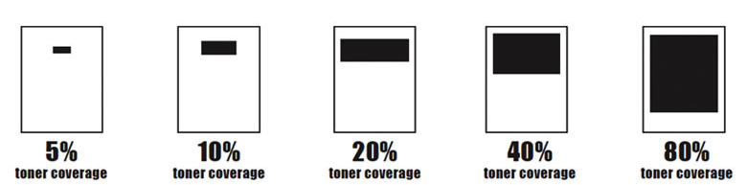
Examples of coverage by percentage

Another thing to be aware of is that the cartridges that come with a new printer are usually starter cartridges (unless otherwise stated). Starter cartridge usually have half the capacity of a standard cartridge, For this reason, we advise that when you purchase a new printer, you also get a full set of cartridges as the starters contain much less ink/toner than the standard equivalent cartridge.

Printer cartridges can be confusing at the best of times. Sometimes you may come across a cartridge that looks just like the one that came out of your machine, but it will not work in your printer. (This is because of the information on the chip on the cartridge - information about this will be explained in the future). Then the cartridges that work in your printer may have different "sizes". This does not refer to the physical size of the cartridge, it refers to the amount of ink/toner that is in it.

For example, Canon's Pixma 640 black cartridge comes in a standard size (640); an extra large (640XL); and extra, extra large (640XXL). The size of the cartridge does not physically change, but the amount on ink in the cartridge increases with each X.

Toners usually change the cartridge number, but some might just add a letter to indicate if the cartridge is a standard size or a large size (A vs X, or HC for High Capacity).

Here are some tips to reducing that amount of ink/toner your printer is using to print.

- Consider whether or not the document really needs to be printed
- Check and revise the density of the images or text of the document.
  - (ie) Areas that are shaded, bold or large fonts will use more ink/toner.
- Alter the print settings for drafts or non-presentation documents
  - You can default the prints to be in black and white/monochrome/greyscale via the printer or computer. One of the easiest ways if to check the setting while you’re in the document you want printed.

- Consider changing your font
  - Some fonts are denser or larger an will use more ink/toner. (some examples are Impact, Cooper Black and Comic Sans). Some fonts (such as Century Gothic, Times New Roman and Calibri)
- Consider whether or not tables need the borders
- Print from the computer if a soft copy is available (rather than copying a hard copy)
  - Does this really make a difference? It can.
When you print a document it will be a clean print free of any superfluous additions. A copy will be similar to taking a photograph, any shadow, crease, smudge (etc) and even the shade of the paper will be included in the copied print-out. This is the reason copies are rarely as sharp as originals

